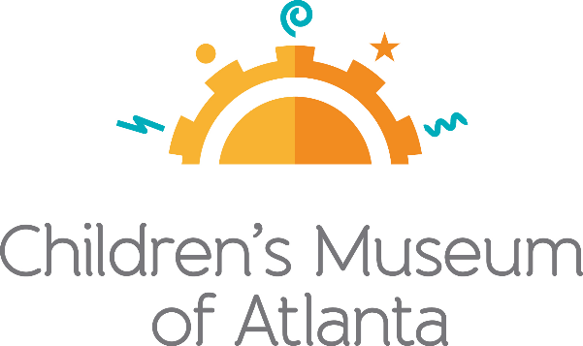

CONTACT
Jennifer Walker
BRAVE Public Relations
404.233.3993
jwalker@emailbrave.com

*MEDIA ADVISORY*
Children’s Museum of Atlanta launches Homeschool Days virtual programs
The programs are designed to bring the Museum’s activities and workshops direct to homes

ATLANTA (August XX, 2020) – Children’s Museum of Atlanta invites the Atlanta community to take part in Homeschool Days, a series of virtual programs with a focus on math, science, language arts and social studies. Each program teaches important concepts using hands-on, at-home learning activities that homeschool students can enjoy. Perfect for kindergarten through grade four, children can get engaged at home beginning Tuesday, August 25 with a lesson in weather, including a “cloud in a cup” activity.

WHAT: CMA Homeschool Days
Hands-on learning activities that kids can do at home.

WHEN: August 25 at 2 p.m. – Head in the Clouds
Aspiring meteorologists will learn about the water cycle, clouds and
what they mean for the weather. Kids will also get the chance to watch a
real cloud form and create their own cloud in a cup!

September 15 at 2 p.m. – Building Challenge
Future engineers will have the opportunity to create something extraordinary with everyday objects they can find in their home.

October 20 at 2 p.m. – Gloopy Glop: Halloween Version
Children will conduct a hands-on experiment when they create Halloween-themed Gloopy Glop!

November 17 at 2 p.m. – Growing Vegetable Soup
Kids will dive into the book “Growing Vegetable Soup” by Lois Ehlert to learn where vegetables come from and how to grow a plant from a seed.

December 15 at 2 p.m. – Glitter Explosion
Kids can experiment with chemistry at home when they concoct this fun, glittery chemical reaction.

HOW: Entry can be purchased on the Children’s Museum of Atlanta website under the Homeschool Days program descriptions here. Tickets must be purchased in advance, no later than one day prior to the program.

For more information or to support Children's Museum of Atlanta,
visit childrensmuseumatlanta.org or call 404.659.KIDS [5437]

